Erick Avalos

7 November 2019

EL ENGR 180DA

Professor Pottie

Week 6 Progress Report

1. **What you planned to do this week.**

The overall goal for this weeks lab was to understand the Raspberry Pi’s built in Bluetooth functionality and learn how to interface two Raspberry Pi’s onto a Bluetooth network.

1. **What you ended up doing this week. Explain what went wrong, what changed, and what kind of successes you may have had. Include screenshots, graphs, images and other details to best explain what happened.**

During this week, I was successful on creating a Bluetooth connection between two raspberry pis and transmitting strings from the client to the server. Through the course of creating the Bluetooth connection we first needed to instantiate the Raspberry Pis into a pair mode. This pair mode was created using terminal where bluetoothctl was utilized to make the devices discoverable, and pairable. Figures 1, 2, and 3 elaborate the process in which the Raspberry Pis become paired.

Once the Raspberry Pis were paired, two scripts were created where the server listened, and the client published data. The client consisted of an infinite while loop that increments a counter for that is published onto a socket. This socket is then read by the server and outputted in the command prompt. Figure 4 displays the outputs when the connection between the Bluetooth connection is instantiated.

1. **What you plan to do next week.**

The plan for next week is to be able to pair the raspberry pis in the group and create a script for which can connect and transmit time information to each address in order.

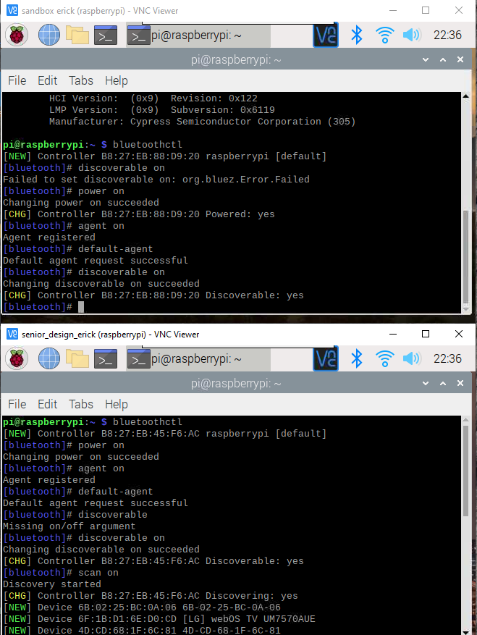

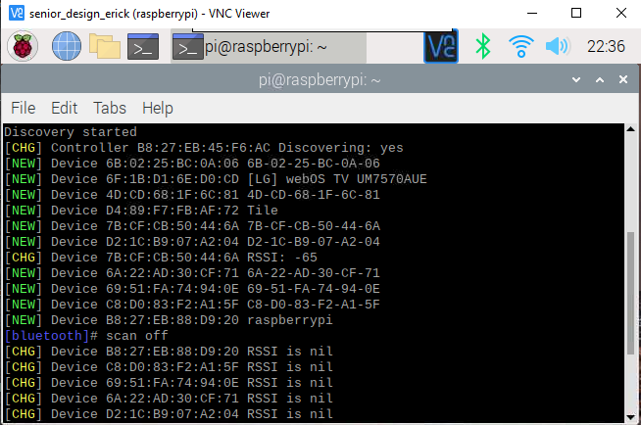*Figure 1: Enabling Discoverable and Pairable*

*Figure 2: Raspberry PI Bluetooth MAC address found*

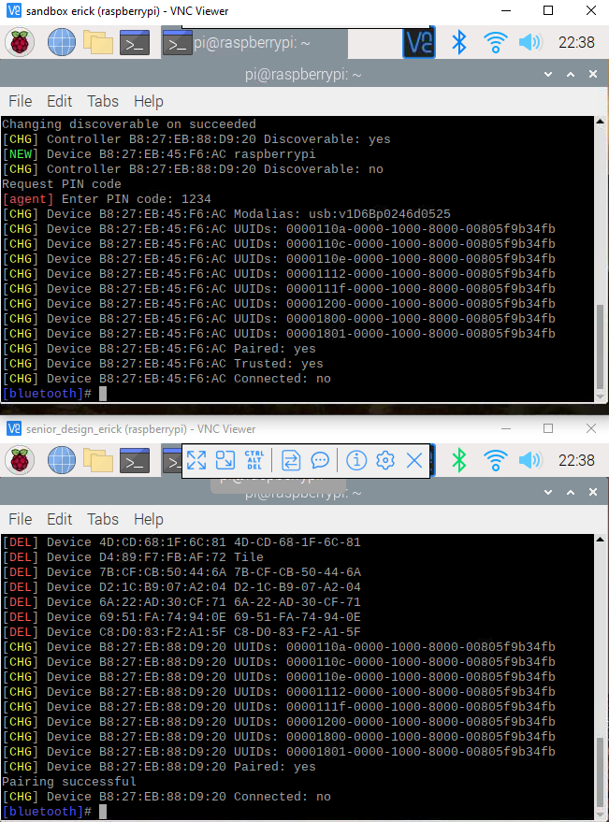

*Figure 3: Pairing Successful*

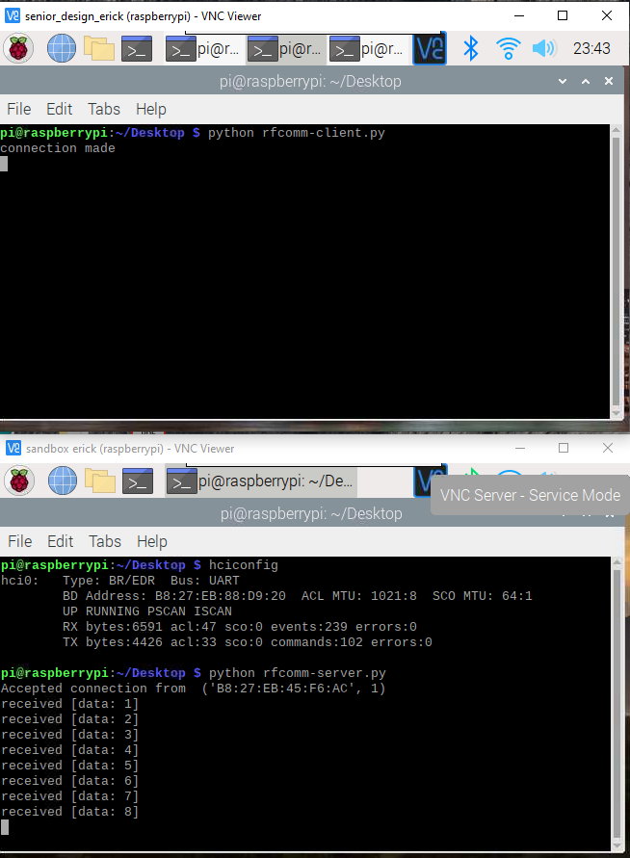

*Figure 4: Data transmission between Server and Client*